**COIMBATORE INSTITUTE OF TECHNOLOGY**

**(Government Aided Autonomous Affiliated to Anna University, Chennai)**

**COIMBATORE – 641014, TAMILNADU, INDIA**



**19MAM58 – Cloud Computing Lab**

**Project Documentation**

**Name** : NAVANEETH GA

**Register Number** : 71762134030

**Title** : DriveMaster - Navigate the Roads with

Code and Nodes

**Title : "DriveMaster: Navigate the Roads with Code and Nodes"**

**Abstract :**

"DriveMaster" revolutionizes driver education by leveraging cloud computing and Kubernetes orchestration. In this innovative project, we integrate cloud technologies to enhance scalability, flexibility, and accessibility in managing the driving school's operations. The application utilizes Kubernetes for container orchestration, ensuring seamless deployment, scaling, and management of our software components. With cloud infrastructure, our driving school achieves improved resource utilization, increased reliability, and simplified maintenance. Through Kubernetes, we streamline the deployment of microservices, fostering a resilient and efficient ecosystem. This project showcases the power of cloud-native architecture and Kubernetes in optimizing the driving school's digital infrastructure, promising a modern, agile, and robust experience for both students and administrators. Embrace the future of driving education with DriveMaster's cloud-powered, Kubernetes-driven solution.

**Introduction :**

Welcome to DriveMaster Academy, your gateway to mastering the art of driving with precision and confidence. Our mission is to cultivate a community of safe and skilled drivers, empowering individuals to navigate the roads responsibly.

At DriveMaster Academy, we blend expertise, innovation, and a passion for road safety to deliver top-notch driver education. Whether you're a novice seeking your first license or an experienced driver looki

ng to enhance your skills, our comprehensive programs cater to learners of all levels.

Our team of professional instructors, led by visionary founders John Doe and Jane Smith, is dedicated to providing an enriching and supportive learning environment. With modern training vehicles, flexible scheduling, and a commitment to safety, DriveMaster Academy is the destination for those aspiring to be proficient and responsible drivers.

Explore our courses, connect with our experienced mentors, and embark on a journey where roads become avenues of skillful mastery. Join us at DriveMaster Academy – where the road to driving excellence begins!

**System Design :**

DriveMaster Academy employs a modular system design that seamlessly integrates cloud computing and Kubernetes into its architecture, elevating the driving school experience to new heights. The foundational components, including user authentication, course management, and communication, are strategically orchestrated within Kubernetes pods, ensuring optimal resource utilization and efficient scaling. The cloud infrastructure, with its elastic and on-demand nature, empowers DriveMaster to handle varying workloads effortlessly, enhancing the overall reliability and availability of the system.

In this innovative setup, Kubernetes serves as the orchestrator, efficiently managing the deployment and scaling of microservices that make up the core functionality of the driving school platform. The responsiveness of the front-end, crafted with HTML, CSS, and JavaScript, is seamlessly integrated with the cloud-native architecture. This integration not only ensures a fluid and engaging user interface but also aligns with the scalability goals of DriveMaster. By embracing cloud and Kubernetes technologies, DriveMaster Academy is poised to adapt dynamically to user demands, providing a responsive and scalable platform that evolves with the ever-changing landscape of driver education.

Furthermore, the utilization of cloud-based storage and data management within Kubernetes clusters enhances the security and accessibility of user data, fostering a robust and resilient infrastructure for DriveMaster Academy. This approach not only optimizes the user experience but also lays the foundation for a future-proof driving school ecosystem that can effortlessly evolve alongside advancements in cloud and Kubernetes technologies.

**Code :**

**@Index.html**

<body>

    <div class="container">

        <h1>Welcome to DriveMaster Academy</h1>

        <div class="general-info">

            <div class="container-section about">

              <h2>About Us</h2>

              <p> DriveMaster Academy is a premier driving school committed to providing high-quality driver education. Our mission is to empower individuals with the knowledge and skills needed to become safe and responsible drivers for life.   </p>

              <p> At DriveMaster, we take pride in our team of professional and certified instructors who are dedicated to delivering comprehensive and engaging driving lessons. Whether you are a beginner or looking to enhance your driving skills, we have tailored programs to suit your needs.    </p>

              <p> Our modern training vehicles, state-of-the-art facilities, and emphasis on safety create an optimal learning environment. We believe in fostering a supportive atmosphere where students feel confident and at ease behind the wheel.        </p>

              <p> Join DriveMaster Academy and embark on a journey towards becoming a skilled and responsible driver. Your safety is our priority, and we are here to guide you every step of the way.         </p>

            </div>

            <div class="container-section features">

                <h2>Features</h2>

                <ul>

                    <li><i class="fas fa-user-tie"></i> Professional Instructors</li>

                    <li><i class="fas fa-car"></i> Modern Training Vehicles</li>

                    <li><i class="fas fa-clock"></i> Flexible Scheduling</li>

                    <li><i class="fas fa-shield-alt"></i> Safe and Supportive Environment</li>

                </ul>

            </div>

            <div class="container-section courses">

              <h2>Courses with Fee</h2>

              <table>

                  <tr>

                      <th>Course</th>

                      <th>Duration</th>

                      <th>Fee</th>

                      <th>Description</th>

                  </tr>

                  <tr>

                      <td>Basic Driving Course</td>

                      <td>2 Weeks</td>

                      <td>Rs.10000 (With License)</td>

                      <td>   Our Basic Driving Course is designed for beginners who want to build a strong foundation in driving skills.This course covers the essential aspects of driving, including traffic rules, basic maneuvers, and road safety.

                          Perfect for those getting behind the wheel for the first time.

                      </td>

                  </tr>

                  <tr>

                      <td>Advanced Driving Course</td>

                      <td>4 Weeks</td>

                      <td>Rs.20000 (With License)</td>

                      <td>

                          Take your driving skills to the next level with our Advanced Driving Course. This comprehensive program focuses on advanced techniques, defensive driving, and handling challenging road situations. Ideal for experienced drivers looking to enhance their proficiency on the road.

                      </td>

                  </tr>

              </table>

          </div>

            <div class="container-section feedback">

                <h2>Student Feedback</h2>

                <p>

                    "I had a great experience learning to drive at this school. The instructors

                    were patient and knowledgeable, and I felt well-prepared for my driving test."

                </p>

            </div>

            <div class="container-section mentors">

              <h2>Meet Our Mentors</h2>

              <div class="mentor">

                  <div class="mentor-item">

                      <img src="Mento1.jpg" alt="Mentor 1">

                      <p><strong>Tharun Kumar</strong><br>Senior Instructor</p>

                  </div>

                  <div class="mentor-item">

                      <img src="Mentor1.jpg" alt="Mentor 2">

                      <p><strong>Pradeep</strong><br>Driving Specialist</p>

                  </div>

                  <div class="mentor-item">

                      <img src="Mentor2.jpg" alt="Mentor 3">

                      <p><strong>Naveen</strong><br>Advanced Driver Trainer</p>

                  </div>

              </div>

          </div>

        <div class="buttons">

            <button onclick="downloadBrochure()">Download Brochure</button>

            <button onclick="registerNumber()">Register Here</button>

            <button onclick="contact()">Contact Us</button>

        </div>

    </div>

    <script src="scirpt.js"></script>

**Output :**

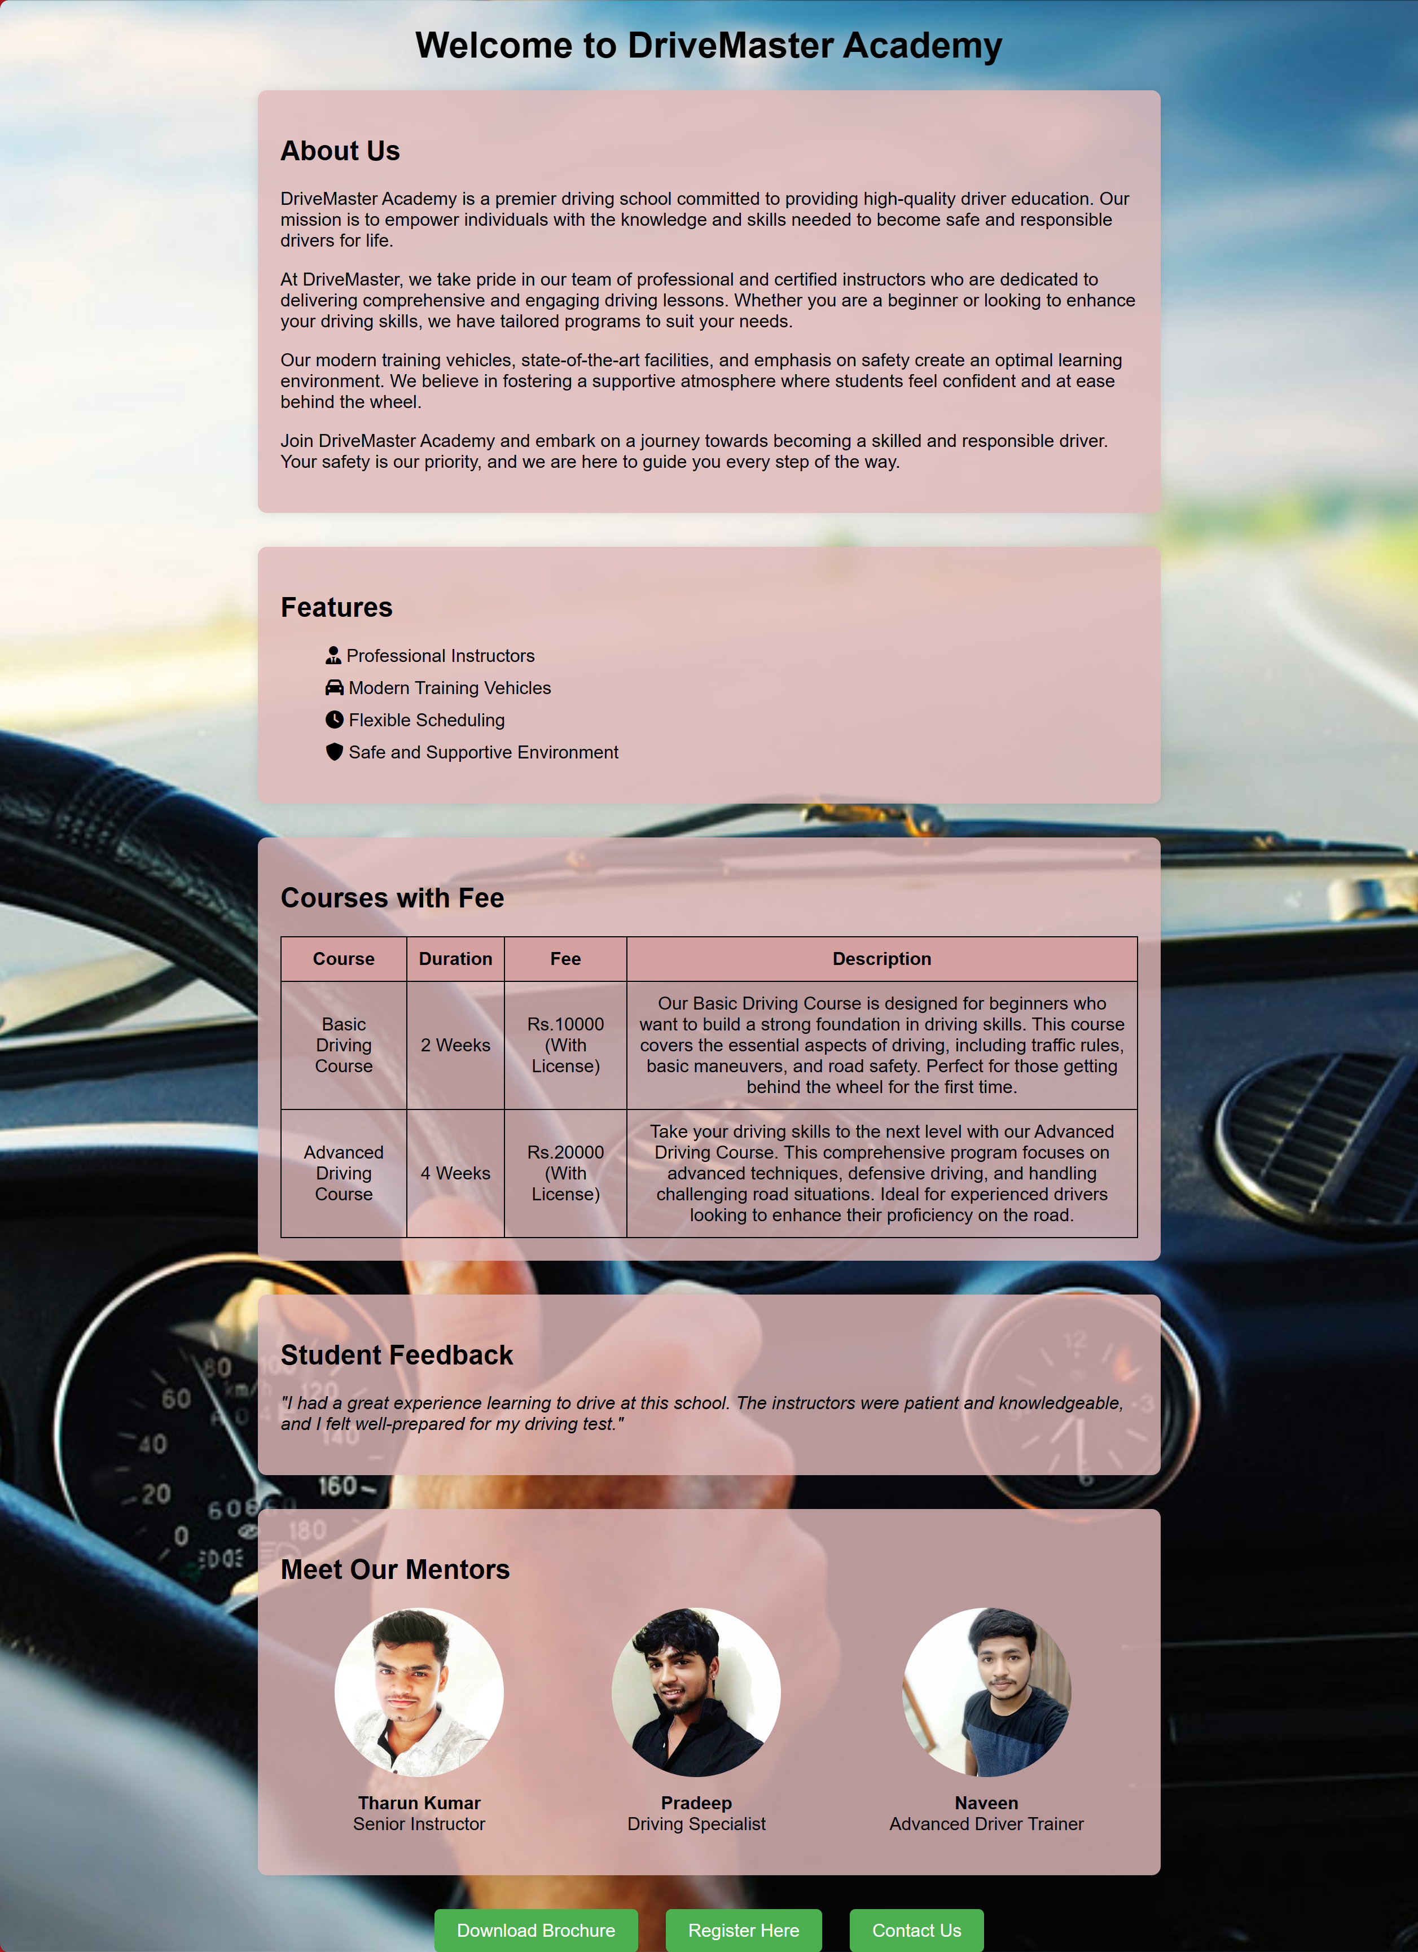

**@ Registration Form**

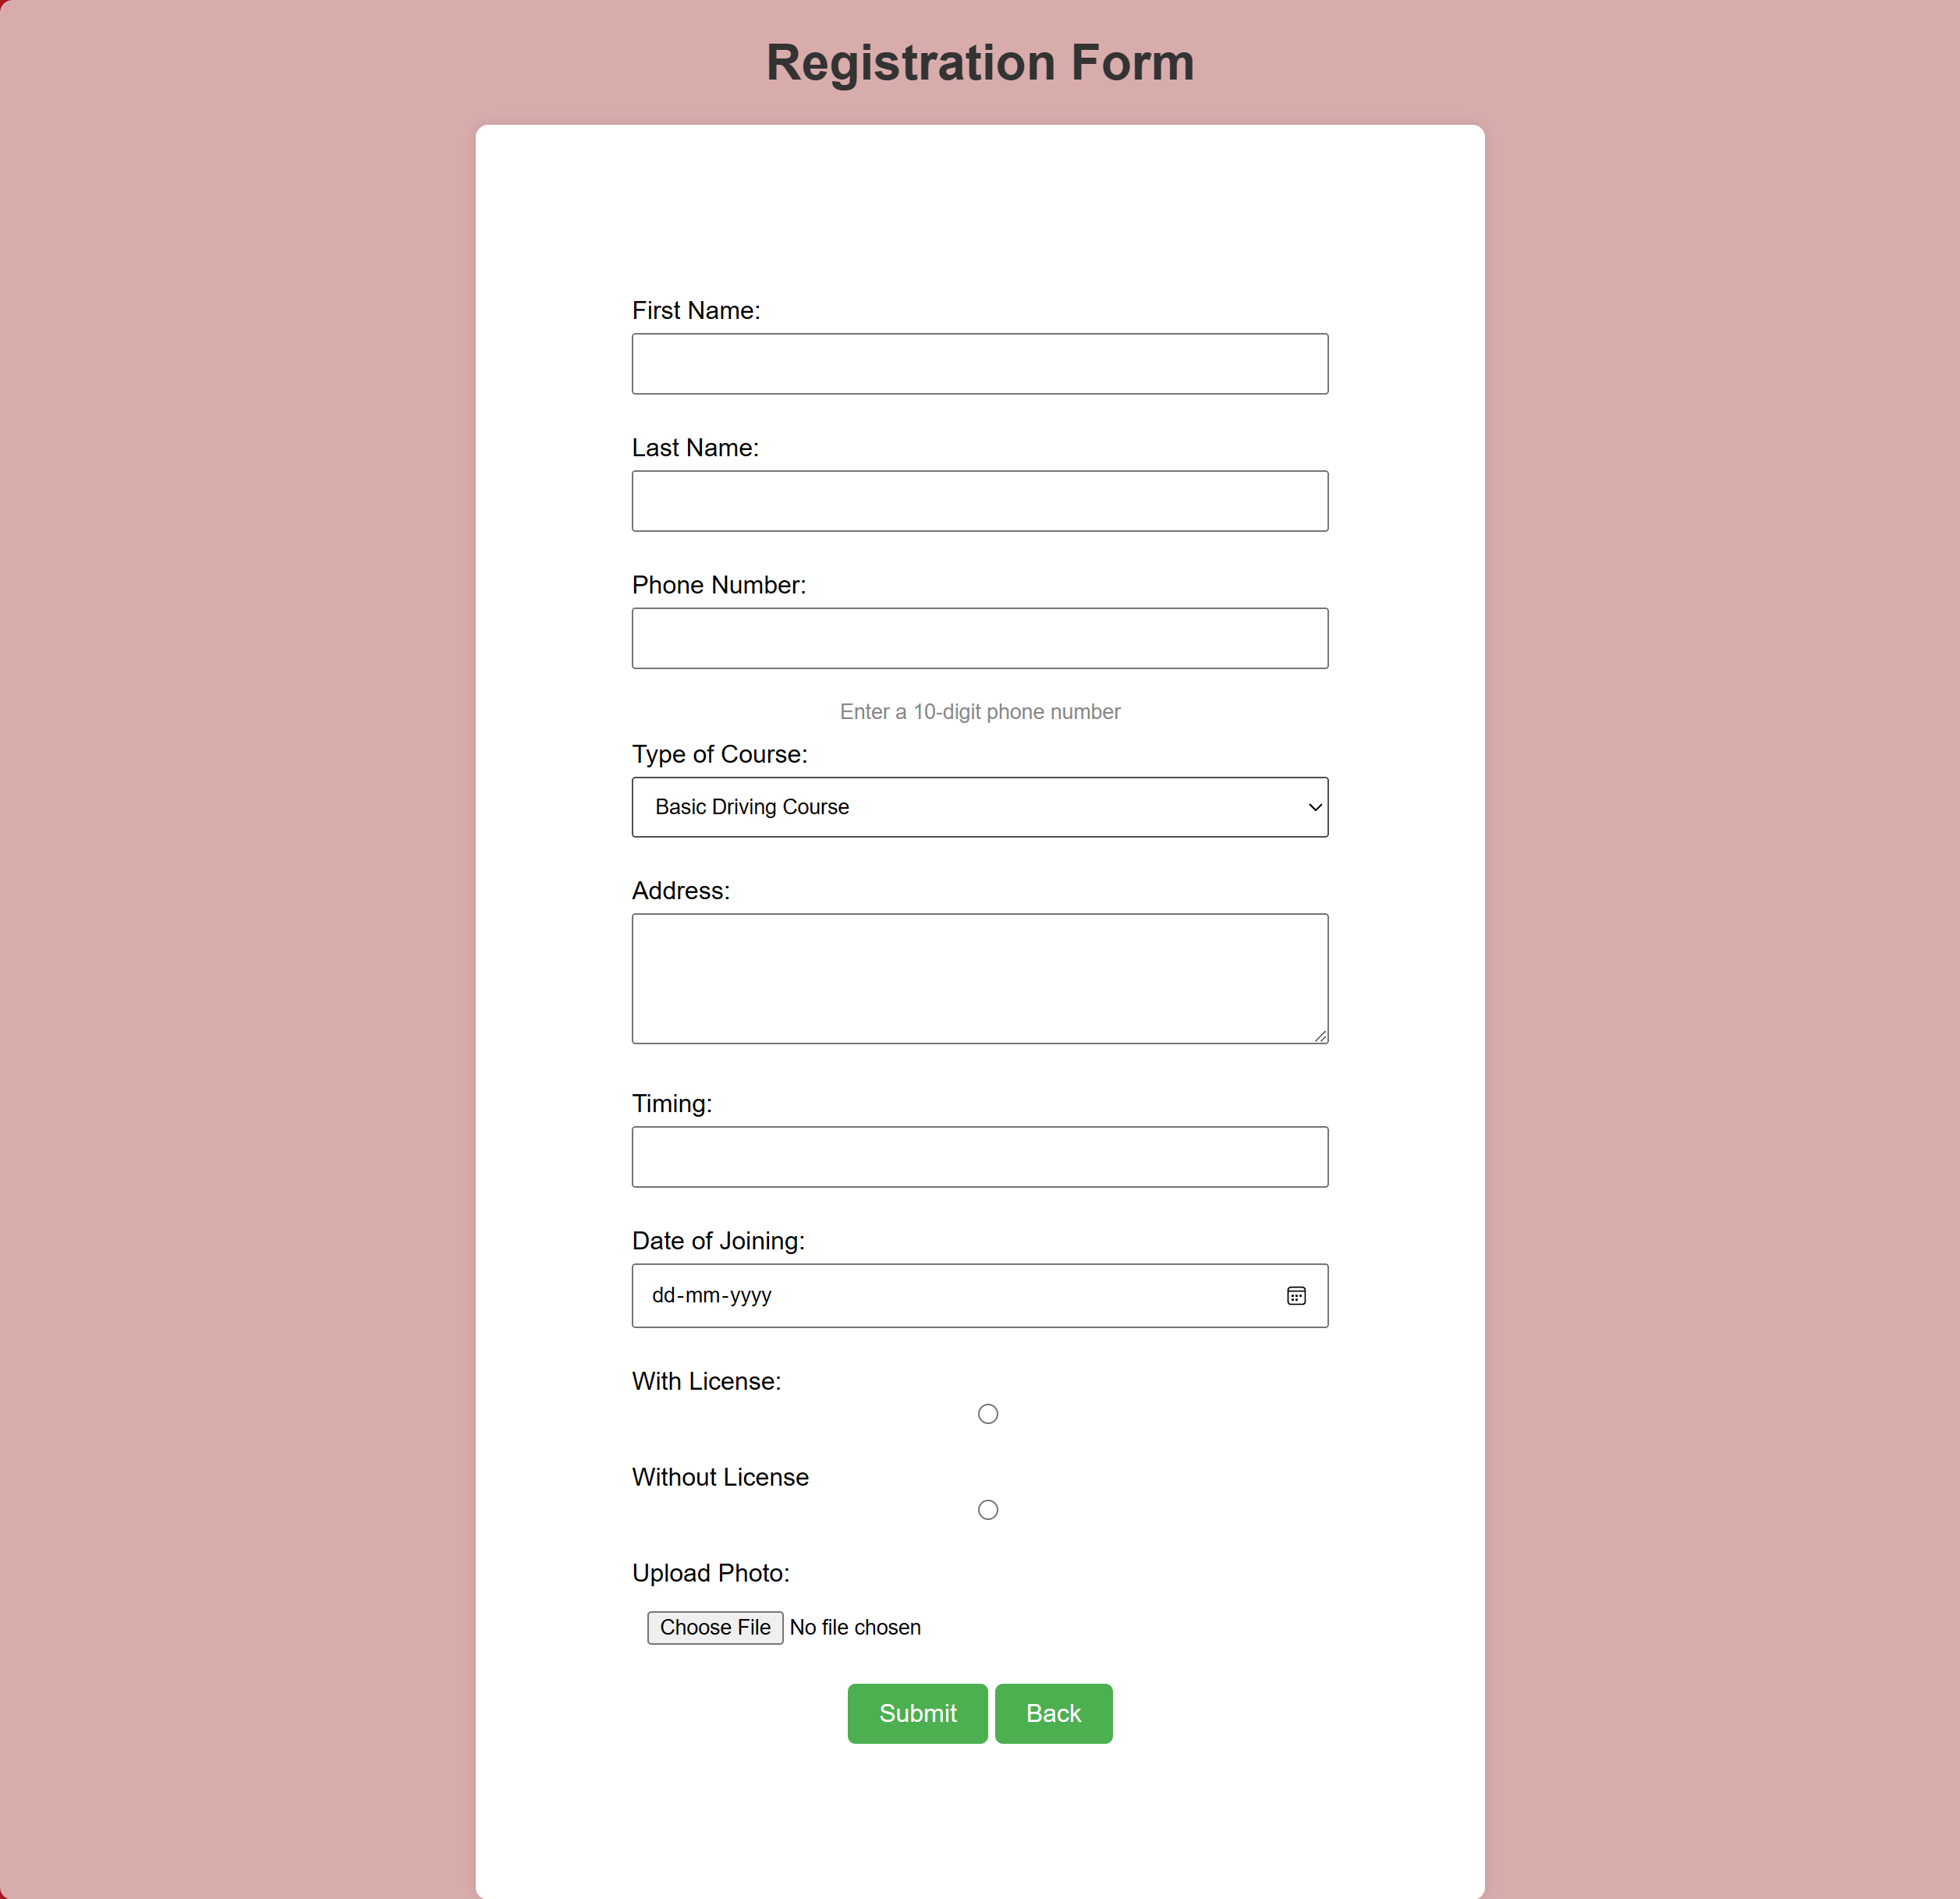

**@ Contact Us**

